# 1. Scenario & Script

The task for the imaginary users is to change the background color of a text-document in Google Docs to a very light green and changing the page-size to A4. This task was given as this is a rather unusual action to do within Google Docs, but not one that is incredibly hard to do. For this project, the Abby persona sheet was not changed.

The task can be changed to the following subgoals:

1. Open the menu to change the background color and the page size.
2. Changing the background color.
3. Changing the page size to A4.

The two GenderMag walkthroughs were done by me and a fellow student of the course. Doing the GenderMag walkthrough was rather difficult, as determining whether Abby would know to do a certain action/subgoal is entirely dependent on whether she has done such a change before or not. There’s also a lot of subjectivity going into this determination, so the scientific integrity of this evaluation is quite questionable.

# 2. Gender Mag Walk-through

## 2.1 Walk-through 1

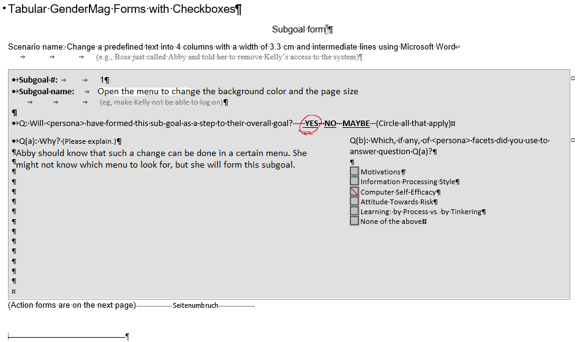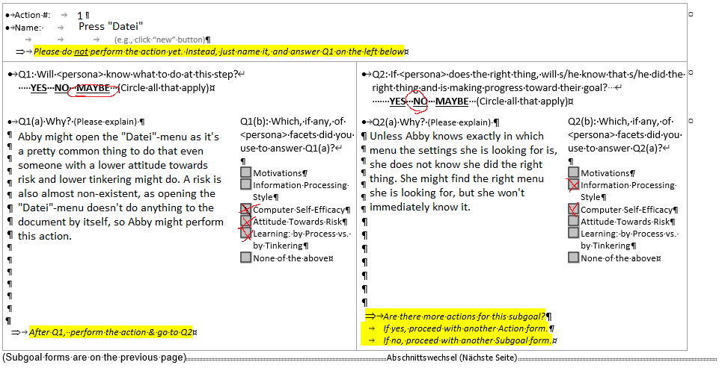

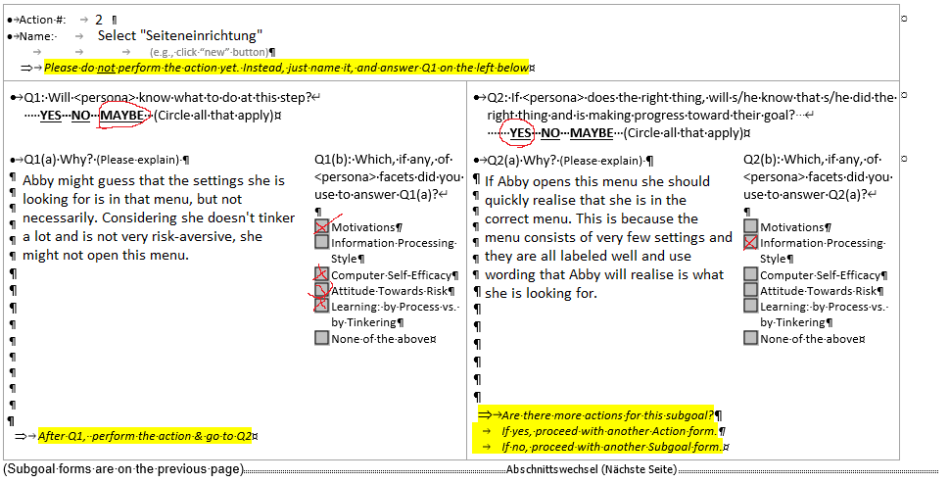

## 2.2 Walk-through 2